Q no 9. What Is push ,pull and comit ? explain with example?

Ans. **Pushing** refers to sending your committed changes to a remote repository such a repository such as a repository hosted on github. For instance if you change something locally,you’d want to then push those changes so that others may access them.

**Pull** requests let you tell others about changes you've pushed to a branch in a repository on **GitHub**. Once a **pull** request is opened, you can discuss and review the potential changes with collaborators and add follow-up commits before your changes are merged into the base branch.

**Commit**. A **commit**, or "revision", is an individual change to a file (or set of files). It's like when you save a file, except with **Git**, every time you save it creates a unique ID (a.k.a. the "SHA" or "hash") that allows you to keep record of what changes were made when and by who.

Qno 1. Command for searching pattern line by line in any document with example?

Ans. Grep command is used to searching pattern line by line in any document.

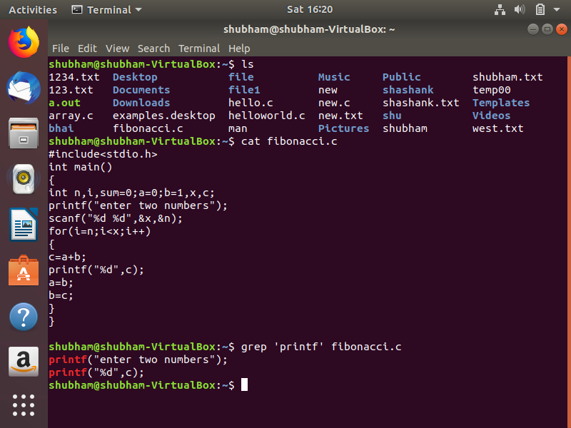

Qno 2. What are all the permissions are there in linux? State all permission and different way of changing permission with example?

* Ans. **Read:** This permission give you the authority to open and read a file. Read permission on a directory gives you the ability to lists its content.
* **Write:**The write permission gives you the authority to modify the contents of a file. The write permission on a directory gives you the authority to add, remove and rename files stored in the directory. Consider a scenario where you have to write permission on file but do not have write permission on the directory where the file is stored. You will be able to modify the file contents. But you will not be able to rename, move or remove the file from the directory.
* **Execute:**In Windows, an executable program usually has an extension ".exe" and which you can easily run. In Unix/Linux, you cannot run a program unless the execute permission is set. If the execute permission is not set, you might still be able to see/modify the program code(provided read & write permissions are set), but not run it.

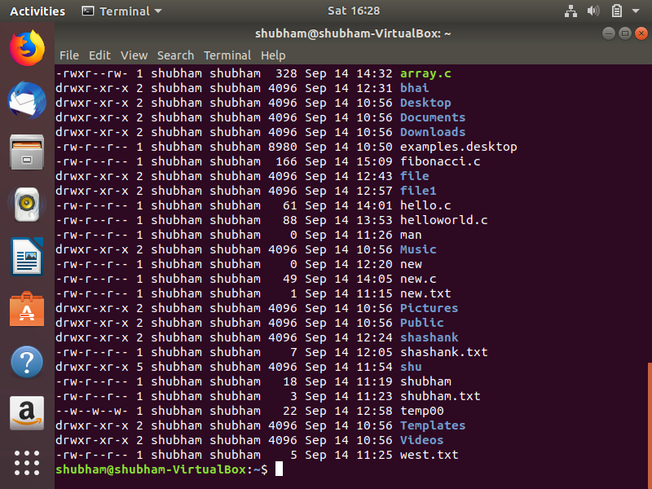

Qno 3. Create a folder OSOC and inside that another folder Inductions and now create a file task.txt inside Inductions with some content now copy this file into another folder Workshop in OSOC.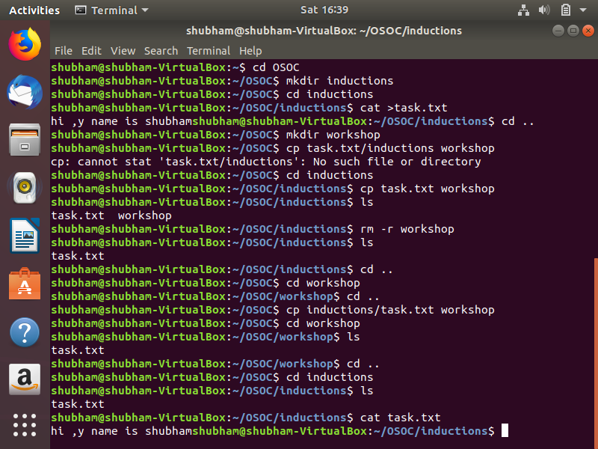

Ques 4. I want to check whether my system is connected to any network or not, please suggest appropriate command for this.

Ans. For this we use netstat –a.

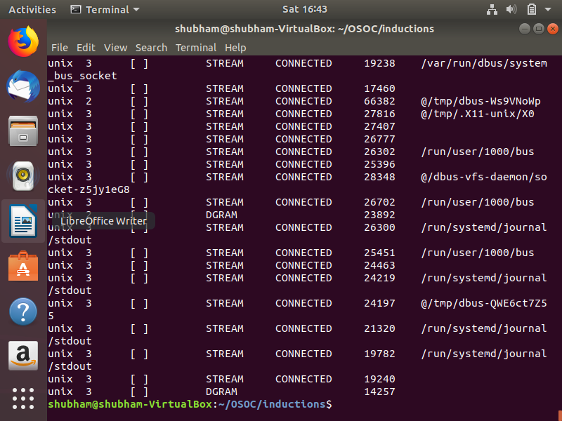

Ques 5. I want to change password of another user how will I do that?

Ans . for changing password we use passwd command.

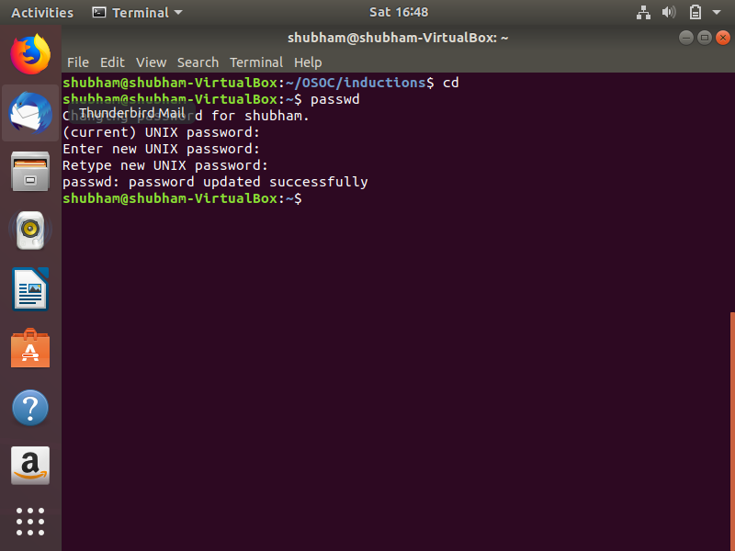

Ques 6. Using shell scripting write program for sort an Array. Input should be taken from user.

Ans. 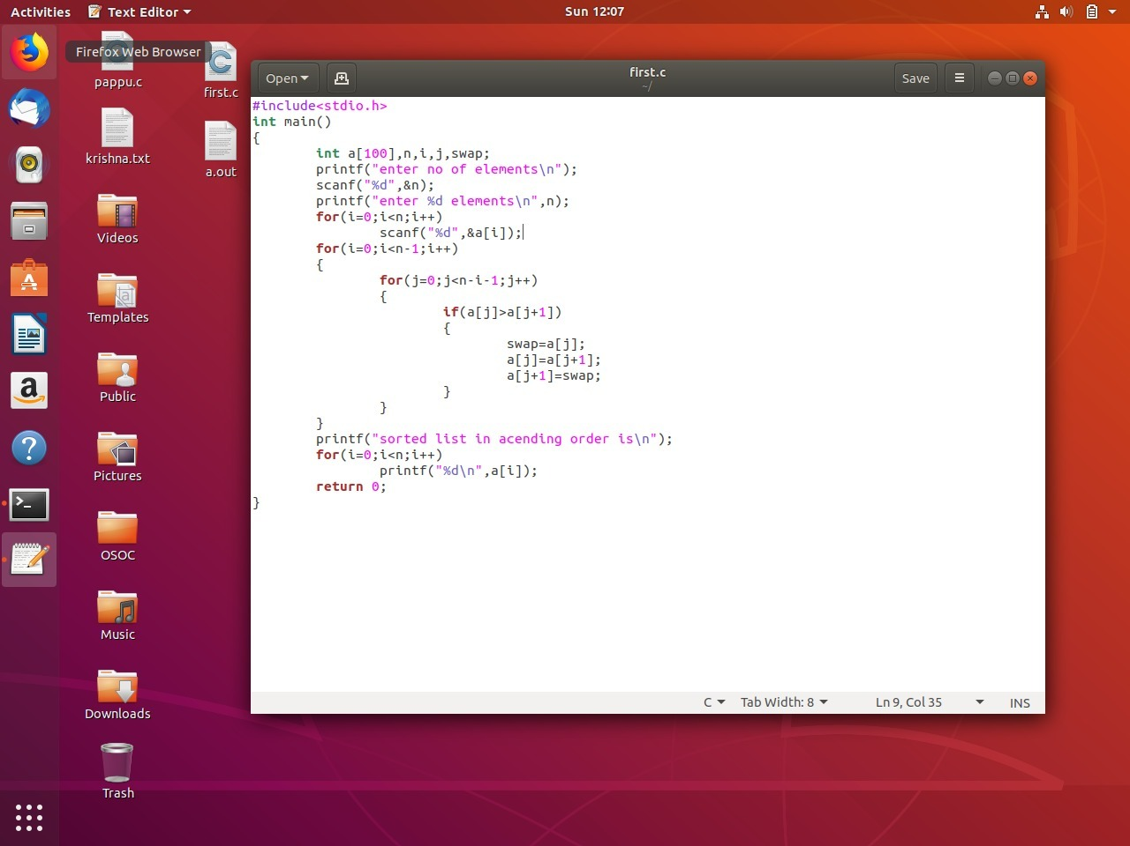

Ques 7. Using Shell scripting write a program to reverse a string. Input should be taken from user.

Ans. 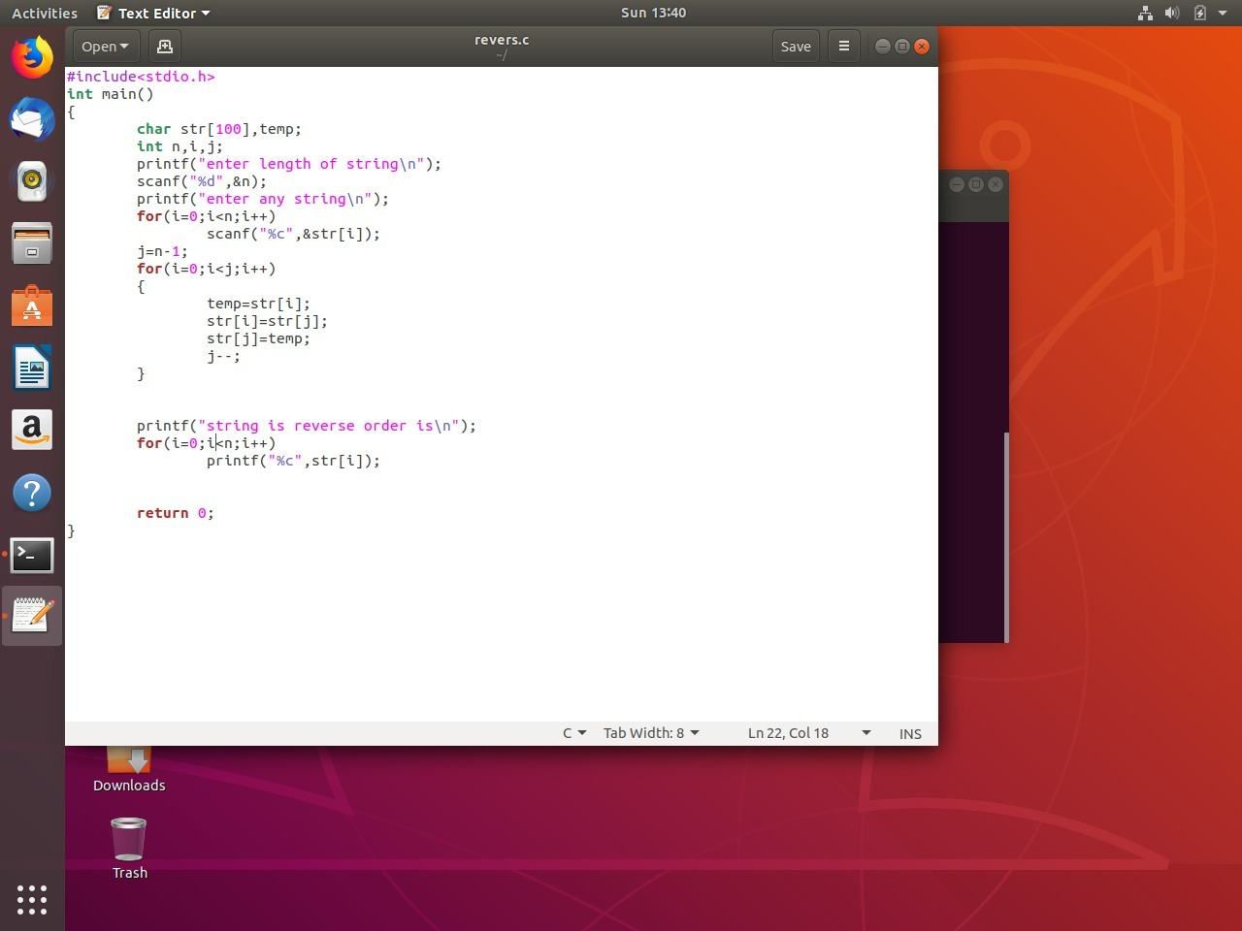

Ques 8. 

Ques 8. What is the concept of Branching? How it is useful? Explain with working example.

Ans. A branch represents an independent line of development. Branches serve as an abstraction for the edit/stage/commit process. You can think of them as a way to request a brand new working directory, staging area, and project history. New commits are recorded in the history for the current branch, which results in a fork in the history of the project.